Ville Hokkinen 2631901 Weekly diary Digital Fabrication
Week 1
Kick of and brainstorming. We come up with home automation window blinds opener. Some buzzing on how to implement it and finish the introductory report. The initial drafts I made with paint by drawing block. It came out great.
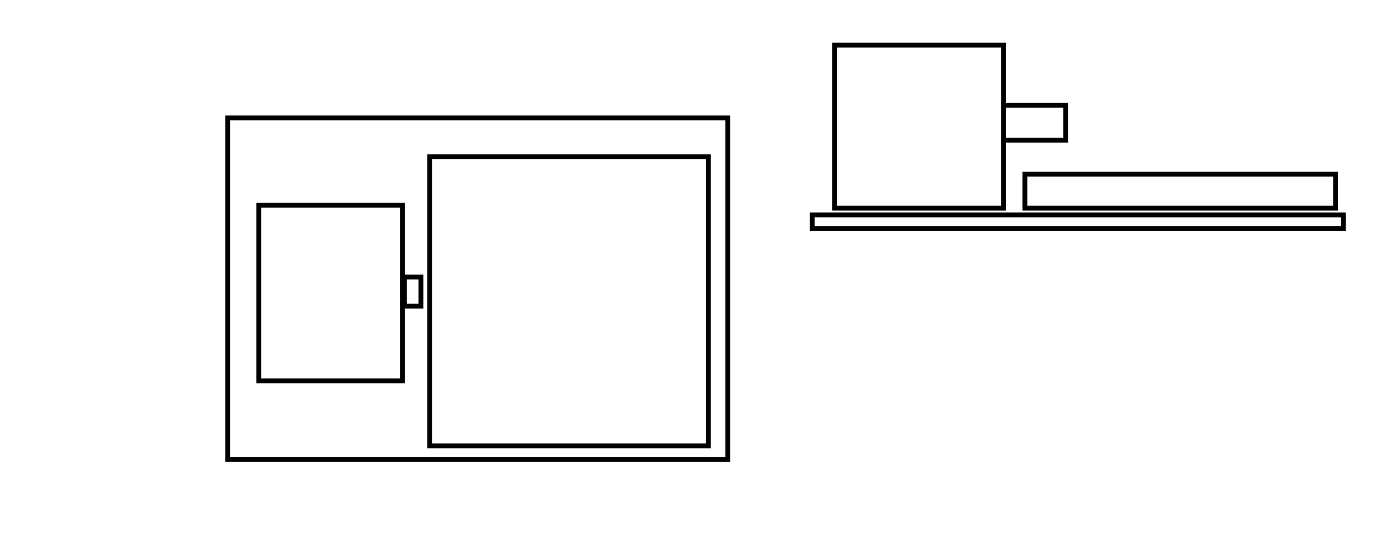
Week 2
I chose to 3D model the adapter between blinds and motor.

Week 3
Started modelling 3D adapter between the motor and the blinds. Created the body for adapter. I was using Autodesk fusion 360 and I haven’t use it so much so lot of youtube videos.

Week 4
Continued 3D modelling and finished adapter with right sizes molds for connecting adapter between blinds and adapter. Hard was find the way to create holes for molds. Youtube for the win.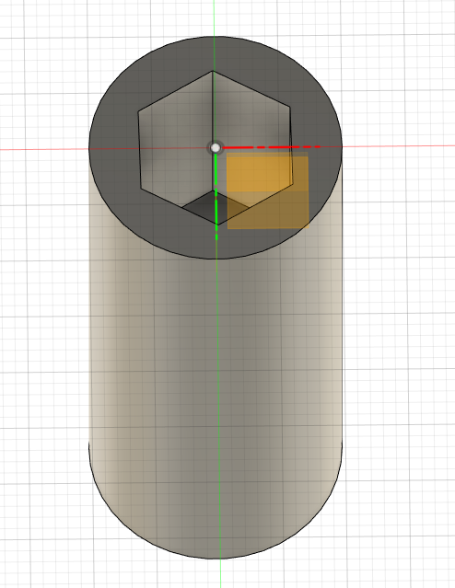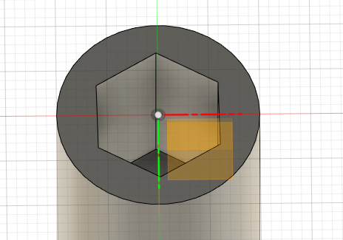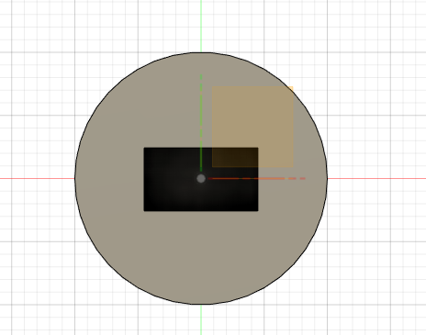

Week 5
I checked one last time my adapter and that the dimension are right. Also helped team with code and simulation. We were still bit lost with circuit but we made progress.

Week 6
Did the rest of the work with team and we finished.

Summary: Fun project and lots of new things for me at least. I think it would been lot easier if we would get the real parts and tried to build it.

